

Structural Design

(Inside View)

**Vertical corrugation**

241*/*8 

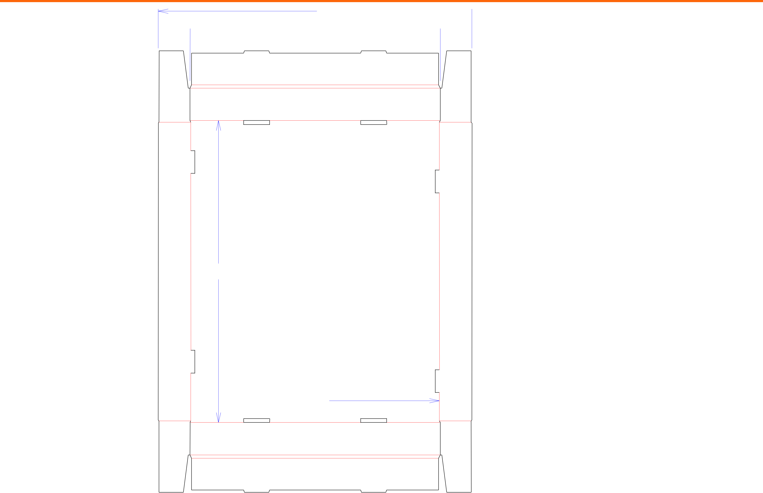

 191*/*4 

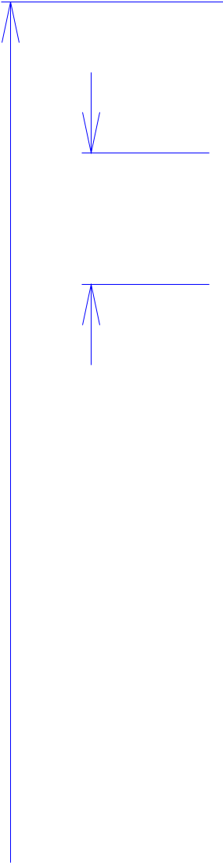

21*/*2

34 231*/*4

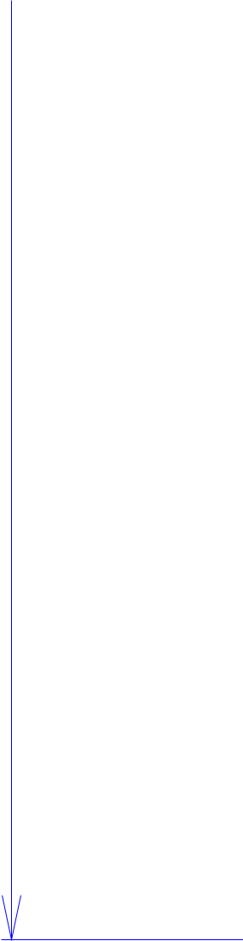

 191*/*8



Cut Crease Crease with Matrix Cut Crease Half Knife Cut Tear Tape Perforation



Design#:

**130331-01**

Customer:

**DeMet's Candy**

Description:

**Tray- 5oz Flips qtr plt**

**SINGLE-OUT DRAWING**

Qty/Unit: **4**

Style: **NJDC**

Board: **B flute**

Combination: **NA - NA - NA**

I.D. : **22+5/8 x 19 x 2+1/2**

Area of Blank - Waste : **5.6 sq. ft.**

Waste on Blank : **1.77%**

Finished Piece Weight: **0.01 lbs./5.86g**

Over-all Blank: **34 x 24+1/8**

**D/C from INSIDE**

**Matrix Highlighted Scores**

**EMBOSS**

Notes:

Revision Info: **[0] 04/10/2013**

Designer: **Alan Groff**

Designright and Copyright of DS Smith Corrugated Packaging Ltd. This technical Specification is subject to Manufacturing tolerances. Drawing dimensions shown are crease to crease. Date printed: 05/03/2019